The Importance of Identity in Preparing a Diverse Computing Workforce

A. Nicki Washington, Ph.D. and Anna Romanova, Ph.D.
Winthrop University
College of Business Administration
Rock Hill, SC 29733

Abstract
As one of the fastest growing disciplines in the United States, computing suffers from a lack of qualified candidates as well as diversity. Underrepresented minorities represent a grossly small percentage of computing graduates, yet an increasingly larger percentage of the population. In this work, we present identity as an important factor to improving underrepresented student interest and participation in computing. Results indicate identity is an important measurement for underrepresented students in computing, and ultimately, diversifying the computing workforce.

Introduction
Computing is one of the fastest growing disciplines in the country. According to the U.S. Bureau of Labor and Statistics, 50% of all U.S. jobs will be in computing by the year 2020. Despite its rapid development, it is the only industry where there continues to be more positions available than qualified graduates prepared to fill them. Currently, there are approximately 490,000 open computing positions nationwide (Code.org). However, in 2017, only 43,000 computer science students graduated into the workforce. In 2005, Dr. Shirley Jackson first coined the phrase “The Quiet Crisis” to describe the large gap forming between the available STEM positions due to baby-boomers retiring and the lack of qualified graduates prepared to fill them. The innovative and disruptive nature of computer science has exacerbated this crisis in the discipline, as new technologies (and subsequently, new positions) are introduced daily. Many of these jobs cannot rely on offshore hiring, including those related to national intelligence and security. As such, the U.S. is faced with finding ways to increase the number of CS graduates, if it is to remain globally competitive.
One of the well-documented and discussed issues in the U.S. computing workforce is the lack of diversity. The 2016 Google report titled “Diversity Gaps in Computer Science: Exploring the Underrepresentation of Girls, Blacks and Hispanics” states,
“Given the ubiquity of the computing field in society, the diversity gap in computer science (CS) education today means the field might not be generating the technological innovations that align with the needs of society’s demographics. Many –including tech companies and educational institutions-have taken steps to make CS more appealing and accessible to these groups, yet the diversity gap endures.”
According to the Information is Beautiful website (2017), the 2016 annual diversity reports from Silicon Valley tech companies show less than 1-5% of employees in computing-related positions were underrepresented minorities. These percentages are even less for executive positions. These statistics and reports highlight one logical solution to the computing pipeline problem: increasing the percentage of underrepresented employees.
However, increasing this number is not a simple task. According to results of the most recent Taulbee Survey, two-thirds of all bachelor’s degrees conferred in computer science were awarded to white, non-Hispanics, with less than 12% awarded to those identifying as African-American and Hispanic combined. Figure 1 presents the breakdown of CS baccalaureate degrees, by ethnicity.

Figure 1. Percentage of bachelor’s degrees awarded, by race/ethnicity.

While only a small percentage of computing graduates, the U.S. Equal Employment Opportunity Commission reports that African-Americans and Hispanics, combined, comprise approximately 30% of the U.S. workforce, with a projected increase to 40% by the year 2050 (2016). Given the current and projected percentage of the U.S. workforce, this is an important and untapped demographic for quelling the “Quiet Crisis.” Preparing a diverse student body to pursue computing degrees and careers will not only fill requisite and currently unfilled jobs, but also ensure a more diverse workforce of qualified U.S. citizens are in positions critical to the nation’s competitiveness, productivity, and security.
Factors Impacting Diversity in Computer Science
The lack of diversity in computer science (CS) can be summarized into the following major factors:
- No formal K-12 CS curriculum for many school districts. Research shows that attracting and engaging students in the computer science pipeline must occur as early as possible. Previously, most of the effort and research on K-12 CS education was focused on preparing students for AP Computer Science (Goode 2007 2010). However, many schools lack a CS curriculum that incrementally exposes students to computer science and teaches core fundamentals leading to AP CS, if desired. Over the last two years, this has changed with the development of the K-12 CS Framework (2016) and the introduction of K-12 CS standards for many states, including South Carolina (2017), Maryland (2016), Massachusetts (2015), and Arkansas (2015). However, there is a still significant work required to ensure that every school in every district has a proper CS curriculum.
- Many college students are ill-prepared for introductory computing courses. Researchers identified that over half of all college students are not well informed about CS (Goode 2008). If offered, many high schools do not offer introductory-level courses to successfully prepare students for AP Computer Science or undergraduate CS courses (Goode 2010). In many districts and schools, AP Computer Science is not offered at all. Instead, the lowest-level introductory computer technology classes are designed to teach students basic computer literacy, including how to use applications such as Microsoft Excel and PowerPoint (Margolis et al. 2010). These courses do not teach fundamentals such as computational thinking and problem solving. While there has been significant progress in creating CS standards for many states, there still exist many schools lacking the resources to introduce and implement a CS course, or hire or train a qualified teacher. This is especially prevalent in schools and districts with higher populations of underrepresented students. As such, if students choose to enter university CS programs, many have no knowledge of what computer science is and/or the requisite skills and coursework to successfully graduate.
- Students find CS boring and/or not applicable to them and their daily lives. Students often associate CS with programming, without much correlation to other technologies and everyday activities that they use and engage in. In addition, underrepresented students do not readily identify it as a field that they can successfully pursue. When asked to identify computer scientists, students affiliate it with White and Asian males (Goode 2008). This, as well as the negative popular perception of engineers projected by characterizations such as “Dilbert,” has depressed interest in CS and STEM in general. Due to a number of factors, including negative perception of being difficult, lack of understanding about and preparation for computer science courses, and a lack of self-representation, many students feel this subject area is not an area that includes them or their interests (Goode 2007), (Margolis et al. 2010, 2015).
- High attrition rates. Even if an underrepresented student enrolls as a first-time freshman in a computer science department, there is still a high likelihood of attrition. The retention rate of underrepresented minorities in U.S. engineering programs is 40% in comparison to 66% of their counterparts (MacKay and Kuh 1994, 1996), (Fuchs, 1997), (NACME 2002), (Zhang et al. 2002), (May and Chubin 2003), (Fleming et al. 2006). Majority of these students leave the major within the first two years. This attrition is due to students being ill-prepared for many of the lower-level CS courses, particularly introductory programming. For many incoming freshmen, these courses are their first experience with CS fundamentals. As a result, students become disillusioned, a key factor in attrition.
If the U.S. intends to grow its domestic computing workforce, the focus must not only include what is taught, but before that, who is academically prepared, mentored, and socialized to computing as a career (Keys and Bryan 2001).
National Efforts to Increase Diversity in Computer Science
In recent years, a nationwide effort has increased focused on exposing a more diverse student population to CS, and/or preparing them for higher-level CS courses in high school, such as CS Principles, and ultimately CS undergraduate programs and careers. This includes leading tech companies such as Google, as well as coalitions of non-profits and government agencies such as Code.org (http://www.code.org), the National Science Foundation (https://nsf.gov), President Obama’s CS for All initiative (https://www.csforall.org/), Exploring CS (http://www.exploringcs.org/), Black Girls Code (http://www.blackgirlscode.com/), Girls Who Code (https://girlswhocode.com/), and state and local agencies and school districts.
The goal of these efforts is to increase the number of underrepresented students (specifically African-American, Hispanic, and women) entering and completing CS degree programs. To meet this goal, each program has one or more of the following objectives:
- Make CS mandatory for all students as early as possible. Studies by the Massachusetts Department of Education (2011) found that students make important decisions on high-school courses as early as 8th grade. This means that they must be exposed to CS as early in their academic careers as possible.
- Making CS curricula relevant to a diverse student body. Traditional CS courses were designed as a one-size-fits-all approach, which resulted in the traditional demographics of White and Asian males mainly pursuing these courses. In order to attract and retain a diverse student body, the curricula must be relevant to what any student experiences in their daily lives. This requires the introduction of culturally relevant pedagogy (Ladson-Billings 2010), as well as role models of the same gender and ethnicity (Washington and Burge 2011).
- Train educators to teach material, as well as understand, appreciate, and encourage diversity. This requires preparing K-12 teachers who have not only content knowledge, but also training in how to teach diverse learners (Margolis et al. 2010). These are included as key concepts in the K-12 CS Framework and most of the new state-based standards.
Identity as a Measurement of Diversity in Computer Science
While exposure to CS and the introduction of K-12 CS courses throughout the country will provide more access to opportunities for more students, this work alone is insufficient to properly prepare, retain, and graduate a more diverse computing workforce. Increasing the participation of underrepresented students in computing requires increasing the inclusion of computing as part of their identity. This is especially important with respect to ethnicity. As previously stated, computer science is often perceived as a field for White and Asian males (Goode 2008).
Even if students have the aptitude to successfully pursue CS degrees and careers, they are often deterred due to a lack of identification with the field as one where they can be successful or see themselves “fitting in.”
While this factor is often implied or discussed indirectly in the context of CS, there is no research that attempts to quantify how students perceive themselves in CS. With the increased focus on diversifying the computing workforce, greater attention must be paid on how underrepresented students identify in computing, with respect to gender and ethnicity, and how to increase this identity.
What is Identity and Why Is It Important?
Ethnic identity is defined as “that part of an individual’s self-concept, which derives from knowledge of membership of a social group (or groups) together with the emotional significance attached to that membership” (Tajfel 1981), (Phinney 1992), (Roberts et al. 1999), (Phinney and Ong 2007). Research suggests that ethnic identity, including the presence of role models of the same ethnicity, directly influences the self-efficacy of minorities in career choices and development, health behaviors, and more (Gushue and Whitson 2006), (Yancey, Siegel, and McDaniel, 2002).
Ethnicity, specifically ethnic identity, is one of the most overlooked factors when measuring or assessing student interest and participation in computing. This is evident by the fact that, prior to this research, no previously developed assessments included any measure related to it. However, we posit that it is one of the most critical factors when studying the participation of underrepresented students in computing, more so than gender. If properly measured, then identity can be used to assess the impact of many of the current and forthcoming national K-12 efforts to increase diversity in CS.
The Computing Attitude and Interest Survey (CAIS)
The Computing Attitude and Identity Survey (CAIS) was developed to measure five important constructs that influence the attitudes and identities of undergraduate CS students:
- Confidence - Student confidence in abilities to learn computing concepts.
- Interest - Student interest in computing.
- Gender - Student perceptions of computing as a male-dominated field.
- Professional - Student perceptions of computing professionals.
- Identity - Student beliefs about computing in relation to ethnicity.
Prior to this work, all of the research measuring student attitudes, interest, and identities in computing measured only constructs 1-4, at best (Dorn and Tew 2015), (Brown and Matusovich 2013), (Faber et al. 2013), (Forssen et al. 2015), (Hilpert et al. 2010). While they considered identity with respect to gender, prior work did not consider or measure the impact of ethnicity, more importantly ethnic identity, with respect to computing.
Table 1 lists all questions that comprise the CAIS, organized by construct. The tool was previously validated and verified using current and prior CS students of color, based on the aforementioned constructs (Washington et al. 2015). The modified tool also includes demographic questions on race/ethnicity, gender, classification, major, and prior computing experience. A four-point Likert scale was used, to ensure participants chose a positive or negative response to each question.
Table 1. CAIS questions, by construct.
Confidence | - I am comfortable with learning computing concepts.  - I have little self-confidence when it comes to computing courses.  - I do not think that I can learn to understand computing concepts.  - I can learn to understand computing concepts.  - I can achieve good grades (C or better) in computing courses.  - I am confident that I can solve problems by using computing.  - I am uncomfortable learning computing concepts.
Interest | - I would not take additional computer science courses if I were given the opportunity.  - I think computer science is boring.  - I hope that my future career will require the use of computer science concepts.  - The challenge of solving problems using computer science does not appeal to me.  - I like to use computer science to solve problems.  - I do not like using computer science to solve problems.  - The challenge of solving problems using computer science appeals to me.  - I hope that I can find a career that does not require the use of computer science concepts.  - I think computer science is interesting.  - I would voluntarily take additional computer science courses if I were given the opportunity.
Gender | - I doubt that a woman could excel in computing courses.  - Men are more capable than women at solving computing problems.  - Computing is an appropriate subject for both men and women to study.  - It is not appropriate for women to study computing.  - Men produce higher quality work in computing than women.  - Men are more likely to excel in careers that involve computing than women are.  - Women produce the same quality work in computing as men.  - Men and women are equally capable of solving computing problems.  - Men and women can both excel in computing courses.
Professional | - A student who performs well in computer science will probably not have a life outside of computers.  - A student who performs well in computer science is likely to have a life outside of computers.  - Students who are skilled at computer science are less popular than other students.  - Students who are skilled at computer science are just as popular as other students.
Identity | - I am active in organizations or social groups that include mostly members of my own ethnic group.  - I feel a strong attachment towards my own race/ethnic group.  - I was encouraged to pursue a computer science degree.  - I was encouraged to not pursue a computer science degree.  - I can identify/name computer scientists of the same race/ethnicity as me.  - I believe my performance in computer science courses will be used to generalize how others of the same race/ethnicity will perform.  - Seeing or learning about more computer scientists of the same race/ethnicity would help me be more confident about my abilities as a computer scientist.  - Seeing or learning about more computer scientists of the same race/ethnicity would not affect my confidence about my abilities as a computer scientist.

Research Method
The goal of this study was to determine if identity could be appropriately measured in CS undergraduate students of all ethnicities. The study targeted freshmen students or those taking their first required CS course in their major. This demographic was targeted specifically, as their decisions to enroll in CS courses and pursue computing degrees are more directly influenced by decisions and factors in high school. By assessing this group, it is easier to measure the impact of current K-12 efforts to increase participation in computing of underrepresented students.
It is important to note two things about this study. First, the targeted participants included underclassmen computer science, computer information systems, and mathematics majors. These three majors were chosen because, at most institutions, they all require the same introductory CS courses. Second, the participants completing the survey included students of all races or ethnicities. It was important to begin this research by determining if the tool appropriately measured identity across all races or ethnicities. As previously mentioned, there is no research that discusses or measures identity in the context of CS education. Given the psychology-based research on ethnic identity in non-computing contexts (e.g. influences on self-efficacy, career choices and development, persistence, and behaviors) (Gushue and Whitson 2006), (Yancey, Siegel, and McDaniel, 2002), it was important to first confirm the assumption that the same impact would be experienced in CS students, regardless of race or ethnicity. For example, the overrepresentation of non-minority students (Caucasian and Asian) should result in identity being less important to them, as they do not need to readily search for role models of the same ethnicity or a sense of belonging. Conversely, underrepresented CS students (African-American, Hispanic, and Biracial) should view identity as more important, as they are less likely to see an abundance of representation in CS.
A total of 134 students participated in the assessment over one academic year. Each participant completed the tool at the beginning of the semester. Of the students participating, approximately 43% classified themselves as White/Caucasian, 36% Black/African-American, 1% Hispanic/Latino, 11% Asian/Asian-American, and 9% Other (e.g. multiple races/ethnicities). Freshmen comprised approximately 43% of participants, while sophomores, juniors, and seniors comprised 35%, 15%, and 7%, respectively. Approximately 66% were computer science majors, while 13% were computer information systems, and 22% declared their major as Other. For students declaring their major as “Other,” it was determined these were math majors or dual majors that included a computing-related degree.
There are two important points to note regarding the demographic breakdown of participants in this study. First, Winthrop University, while classified as a predominately white institution (PWI), has the second largest population of Black/African-American students of any university in the state of South Carolina, other than South Carolina State University, an Historically Black College and University (HBCU). Second, the aforementioned research on attrition rates of underrepresented students in CS emphasizes that higher percentages of students enter the major. However, they do not successfully graduate, with many leaving by the end of their freshman or sophomore year. Since majority of the participants were underclassmen and the university-wide, student body is exceptionally diverse for a PWI, it is expected that the percentage of Black/African-American students is slightly higher.
Numerical Results
Participant responses were recoded into a four-point Likert scale (1-Strongly Disagree to 4-Strongly Agree), in order to calculate an average score for the entire set of questions for each respondent. In addition, based on the small percentage of Hispanic/Latino participants, the results were grouped with participants who classified their race/ethnicity as “Other,” to ensure measurable results.
Based on ANOVA test results, a few important pieces of information were determined that supported our research. First, race/ethnicity has an effect on identity perception in the computing field. Figure 2 shows the box plots of the distribution of scores for the identity scale by race. The results were found to be highly-significant, with a p-value of 0.00497.
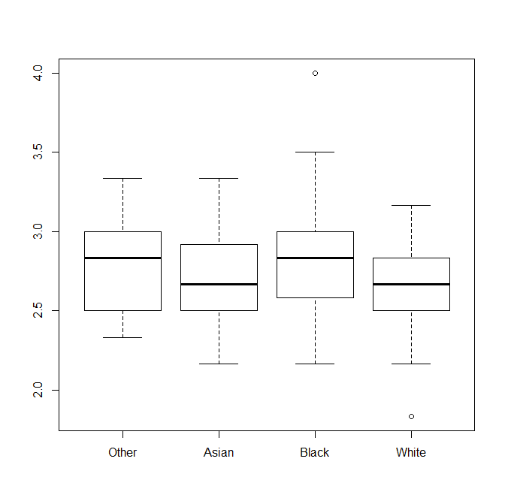
Figure 2. Identity scale, by race.

Traditionally underrepresented students in computing find the identification of ethnicity and identifying with their racial/ethnic group more important, especially in the context of computer science. This includes the importance of identifying computer scientists of the same race/ethnicity in improving confidence in their abilities to succeed in the field. While students from traditionally-represented demographics (e.g. White and Asian) find this less important, it is to be expected, due to the fact that they frequently see representations of themselves in computing. As such, an identity in computing has already been implicitly and sufficiently created and shared with them. This validates our argument on the importance of creating and sharing an identity for underrepresented students.
Figure 3 presents the gender scale differences, by race. These results highlight another important factor: Participants feel very strongly that computing is not a gender-specific field. This is an interesting result, given the research suggesting the underrepresentation of women in CS is due to perceptions of it as a male-dominated field.
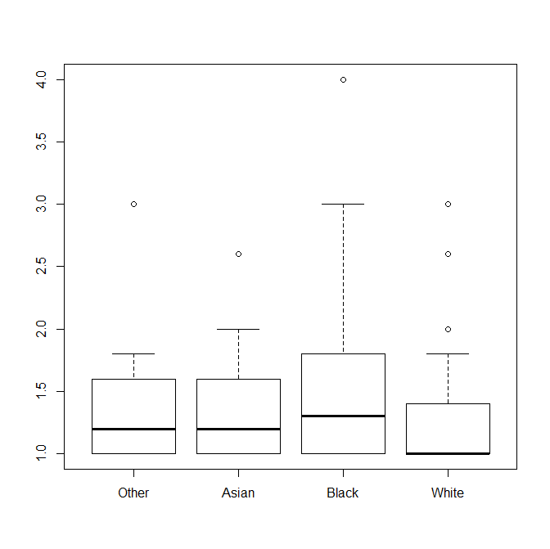
Figure 3. Gender scale, by race.

We also found that the interaction term between race and gender was statistically significant, based on ANOVA test results (p-value of 0.0268). Table 2 presents these results. The interaction term implies that the effect of race on the gender scale varied among female and male students, but only for specific races/ethnicities. Specifically, Black male students appeared to view computing as a more gender-specific field than Black female students, on average. However, gender-related differences in opinions were reversed for students in the “Other” category. Figure 4 illustrates these results.
Table 2. Gender scale, by race and gender.
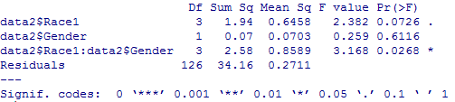

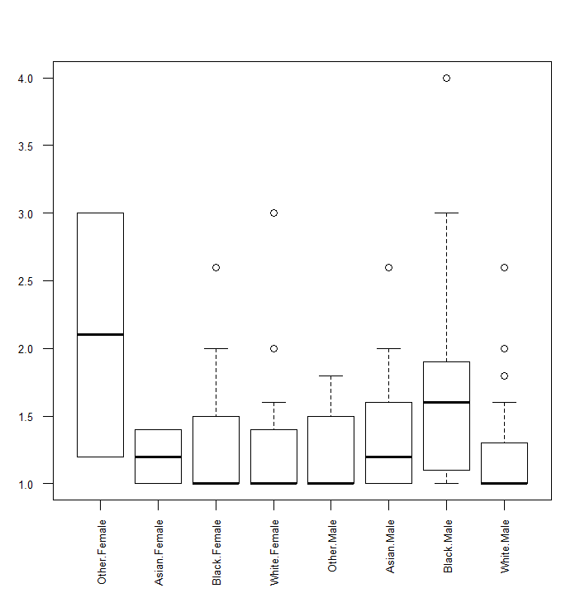
Figure 4. Gender scale differences, by race and gender.

The results of the ANOVA tests illustrate two important factors previously discussed:
- Identity, specifically in the context of ethnic identity for underrepresented students, is important to the same demographic of students in pursuing and completing computing degrees.
- Gender is not as important as ethnic identity in diversifying the tech workforce. This may be due to the fact that participants view their ethnicity as more of a factor than gender in their pursuit of the field. However, differing views regarding gender were more pronounced among underrepresented groups.
Given the information provided, diversifying the tech workforce means rethinking not only who is taught computing, but also how it is taught. While efforts have focused on the former, it is equally important that underrepresented students have access to a diverse computing workforce, including computer scientists of the same race/ethnicity, as well as curriculum that allows them to readily identify themselves as part of the computing culture.
Conclusion and Future Work
Technology will continue to improve and increase in influence across every facet of life and industry. In order to remain globally competitive, the U.S. must employ a diverse, well-trained workforce that is able to enter computing careers upon graduation from post-secondary institutions. Currently, the production of computing graduates is insufficient to meet current and future demands. As such, it is imperative that more students are not only exposed to computing at an early age, but also placed into the computing K-12 pipeline to ensure they are qualified for and interested in computing upon entering colleges and universities.
Research shows that a more diverse computing talent pool and workforce are needed, especially to meet the demand for qualified graduates. However, past efforts to increase the participation of underrepresented students (specifically African-American, Hispanic, and Native American) have been largely unsuccessful in attracting and retaining them. In this work, we discussed the importance of identity in students’ interest in and pursuit of computing degrees and careers. Specifically, establishing an identity in computing that incorporates underrepresented students’ races/ethnicities is critically important to increasing the diversity of the computing workforce.
We established the Computing Attitude and Interest Survey (CAIS) and used the results obtained to illustrate that identity is the critical factor for measuring underrepresented students’ interest and participation in computing. The results indicated that a stronger identity, which closely aligned computing with their races/ethnicities, would result in increased participation and retention in computing.
As part of our future work, we plan to extend this research to assess non-computing majors and high-school seniors, prior to making decisions to enter the university. We also aim to establish a longitudinal study that allows for assessing the same group of participants at the end of their freshmen, sophomore, and senior years. These are three important points in the CS undergraduate pipeline, as the first two are the largest points of attrition and the final year assesses those students who will most likely successfully complete a CS degree.

References
Brown, Philip R. and Matusovich, Holly M., 2013. “Unlocking Student Motivation: Development of an Engineering Motivation Survey.” Paper presented at the 120th Annual Conference and Exposition of the American Society for Engineering Education, Atlanta, Georgia.
K-12 Computer Science Framework, 2016. Accessed April 13, 2017. http://k12cs.org/2016/01/07/announcing-a-new-framework-to-define-k-12-computer-science-education-2/.
Dorn, Brian. & Tew, Allison E. 2015.Empirical Validation and Application of the Computing Attitudes Survey. Computer Science Education, 25(1):1-36.
Faber, Malida, Unfried, Alana, Wiebe, Eric N., Corn, Jeni, Townsend, LaTricia, and Collins, Tracey L. 2013. “Student Attitudes toward STEM: The Development of Upper Elementary School and Middle/High School Student Surveys.” Paper presented at the 120th American Society of Engineering Education Conference, Atlanta, Georgia.
Fleming, L. et al., 2006. “Why Students Leave Engineering: The Unexpected Bond,” Proceeding of the 2006 American Society of Engineering Education Conference and Exposition.
Forssen, A. V., Moskal, Barbara M., & Harriger, Alka. 2015. Measuring the Impact of a High School Intervention on Students' Attitudes in Information Technology: Validation and Use of an Attitude Survey. Computers in Education Journal, 22(2): 2-13.
Fuchs, D., Fuchs, L. S., Mathes, P. G., & Simmons, D. C., 1997. Peer-Assisted Learning Strategies: Making Classrooms More Responsive to Diversity. American Educational Research Journal, 34(1), 174-206.
Goode, Joanne, 2007. “If You Build Teachers, Will Students Come? Professional Development for Broadening Computer Science Learning for Urban Youth.” Journal of Educational Computing Research, 36(1): 65-88.
Goode, Joanne, 2008. Computer science segregation: Missed opportunities. The Voice, 4(2): 2-3.
Goode, Joanne, 2010. “Connecting K-16 Curriculum & Policy: Making Computer Science Engaging, Accessible, & Hospitable for Underrepresented Students.” Paper presented at the 41st ACM Technical Symposium on Computer Science Education, Milwaukee, Wisconsin.
Graham, J. M., and Caso, R. 2002. “Measuring Engineering Freshman Attitudes and Perceptions of their First Year Academic Experience: The Continuing Development of Two Assessment Instruments.” Paper presented at the Frontiers in Education Conference, Las Vegas, Nevada.
Gushue, George V. and Whitson, Melissa L. 2006. The Relationship among Support, Ethnic Identity, Career Decisions and Self-Efficacy, and Outcome Expectations in African-American High School Students. Journal of Career Development, 33(2): 112-124.
Hilpert, Jonathan C., Stump, Glenda, and Husman, Jenefer, 2010. “Pittsburgh Engineering Attitudes Scale - Revised: Evidence for an Improved Instrument.” Paper presented at the 40th ASEE/IEEE Frontiers in Education Conference, Washington, D.C.
Hoegh, Andrew and Moskal, Barbara M. 2009. “Examining Science and Engineering Students’ Attitudes toward Computer Science.” Paper presented at the 39th ASEE/IEEE Frontiers in Education Conference, San Antonio, TX.
“Diversity in Tech.” Information is Beautiful. Accessed April 14, 2017. http://www.informationisbeautiful.net/visualizations/diversity-in-tech.
Jackson, Shirley A. “The Quiet Crisis: Falling Short in Producing American Scientific and Technical Talent.” Building Engineering and Science Talent. Accessed April 14, 2017. http://www.bestworkforce.org/ODFdocs/Quiet_Crisis.pdf.
Keys, Carolyn and Bryan, Lynn, 2001. Co-constructing inquiry-based science with teachers: Essential research for lasting reform. Journal of Research in Science Teaching, 38 (6): 631–645.
Ladson-Billings, Gloria, 1995. But That's Just Good Teaching! The Case for Culturally Relevant Pedagogy. Theory into Practice, 34: 159-165.
MacKay, K. and Kuh, G., 1994. “A Comparison of Student Effort and Educational Gains of Caucasian and African-American Students at Predominantly White Colleges and Universities,” Journal of College Student Development, 3j, 217-223.
Margolis, Jane, Estrella, Rachel, Goode, Joanna, Holme, Jennifer J., and Nao, Kim. Stuck in the Shallow End: Education, Race, and Computing (Cambridge, MA: MIT Press, 2010).
Margolis, Jane, Goode, Joanne, and Binning, 2015. Kevin, “Expanding the Pipeline -Exploring Computer Science: Active Learning for Broadening Participation in Computing.” Computing Research News. 27(9).
Massachusettes Department of Education, 2011. “Increasing Student Interest in Science, Technology, Engineering, and Math (STEM).”
May, G. and Chubin, D. 2003. “A Retrospective on Undergraduate Engineering Success for Underrepresented Minority Students,” Journal of Engineering Education. 1.
National Academy of Engineers. The Engineer of 2020 Project Prospectus.
National Action Council for Minorities in Engineering (NACME), Inc. 2002. “Attention to Retention: A Summary of the Merck-NACME Think Tank on Retention.”
Nocito-Gobel, Jean, Collura, Michael A., Daniels, Samuel, & Orabi, Ismail I. 2005. “Are Attitudes toward Engineering Influenced by a Projected-Based Introductory Course?” Paper presented at the 2005 American Society for Engineering Education Conference and Exposition, Portland, OR.
Phinney, Jean, 1992. The Multigroup Ethnic Identity Measure: A New Scale for use with Diverse Groups. Journal of Adolescent Research, 7(2): 156-176.
Phinney, Jean S. and Ong, Aanthony D. 2007. Conceptualization and Measurement of Ethnic Identity: Current Status and Future Directions. Journal of Counseling Psychology, 54(3): 271-281.
Roberts, Robert E., Phinney, Jean S., Masse, Louise, and Romero, Andrea, 1999. The Structure of Ethnic Identity of Youth Adolescents from Diverse Ethnocultural Groups. Journal of Early Adolescence, 19(3): 301-322.
Searching for Computer Science: Access and Barriers in K-12 Education. Retrieved April 11, 2017. https://services.google.com/fh/files/misc/searching-for-computer-science_report.pdf
Tajfel, Henry. Human Groups and Social Categories (Cambridge, England: Cambridge University Press, 1981).
Taulbee Survey. Computing Degrees and Enrollment Trends. Retrieved April 1, 2017. http://cra.org/wp-content/uploads/2015/06/2014-Taulbee-Survey.pdf.
The College Board. Retrieved March 31, 2017. http://research.collegeboard.org/programs/ap/data/participation/ap-2015.
Toossi, Mitra, 2006. A New Look at Long-term Labor Force Projections to 2050. Monthly Labor Review. Retrieved April 12, 2017. https://stats.bls.gov/opub/mlr/2006/11/art3full.pdf.
U.S. Bureau of Labor Statistics Employment Projections. Retrieved April 10, 2017. http://www.bls.gov/emp/tables.htm.
“Diversity in High Tech” US Equal Employment Opportunity Commission. Retrieved April 10, 2017. http://www.eeoc.gov/eeoc/statistics/reports/hightech.
Washington, Alicia N., Grays, Shaefny, and Dasmohapatra, Sudhipta, 2016. “The Computer Science Attitude and Identity Survey (CSAIS): A Novel Tool for Measuring the Impact of Ethnic Identity in Underrepresented Computer Science Students.” Paper presented at the 123rd American Society of Engineering Education Conference, New Orleans.
Washington, A.N., Burge, L. 2011 Partnership for Early Engagement in Computer Science (PEECS): Exposing and Retaining African-American Middle and High-School Students in the Computer Science (CS) Pipeline. National Technical Association Journal.
Watson, L. and Kuh, G., 1996. “The Influence of Dominant Race Environment on Student Involvement, Perceptions, and Educational Gains,” Journal of College Student Development, 37, pgs. 415-423.
Yancey, Antronette K., Siegel, Judith M., & McDaniel, Kimberly, L. 2002. Role Models, Ethnic Identity, and Health-Risk Behaviors in Urban Adolescents. Archives of Pediatrics and Adolescent Medicine, 156(1): 55-61.
Zhang, G. et al., 2002. “Identifying Factors Influencing Engineering Student Graduation and Retention: A Longitudinal and Cross-Institutional Study,” Proceedings of the American Society of Engineering Education Southeast. Gainesville, FL.

